**Detailed Software Technical Design (DSTD)**

**For**

***V Academy***

By

Arun Kumar S

Shalini A

Hareshaa S K

Table of Contents

1 Introduction 5

1.1 Purpose 5

1.2 Scope 5

1.3 References 5

2 PROJECT OVERVIEW AND USECASE DIAGRAMS 5

3 Detailed Design for Module: <<Module Name>> 11

3.1 Detailed Design for Feature: <<Feature Name>> 11

**3.1.1** **User Profile** 11

**3.1.2** **Navigation Map** 11

**3.1.3** **UI Screen Design** 11

*3.1.3.1* *Screen Layout* 11

*3.1.3.2* *Validations* 12

**3.1.4** **Object Model/Data Flow Design** 12

*3.1.4.1* *Interface Description* 12

*3.1.4.2* *Class Design* 12

3.1.4.2.1 Algorithmic/Business Logic Description (Optional) 12

3.1.4.2.2 Local Data Structure (Optional) 12

*3.1.4.3* *Data Transfer/Value objects* 12

*3.1.4.4* *Related Database Tables* 13

*3.1.4.5* *Dependencies with Other Sub-systems/Components* 13

3.2 Detailed Design for Feature: <<Feature Name>> 13

4 Detailed Design for Module: <<Module Name>> 14

5 Database Design 15

5.1 Entity Relationship Diagrams 15

6 Packaging/Folder Structure and System Artifacts 16

6.1 System Artifacts 16

7 Core Technical Services Design 17

7.1 Persistence 17

7.2 Inter-process Communication 17

7.3 Authentication and Authorization 17

7.4 Error Handling 17

7.5 Logging 17

7.6 Transaction Management 17

7.7 Other Applicable Technical Services 17

8 Non Functional Requirements 18

Appendix 18

1. Design Metrics to be Used 18

2. Supplementary Information 18

3. DQI – Design Quality Index Checklist 18

**Document Revisions**

|  |  |  |  |  |  |
| --- | --- | --- | --- | --- | --- |
| **Date** | **Version** | **Description** | **Author** | **Reviewer** | **Approver** |
|  |  |  |  |  |  |
|  |  |  |  |  |  |

**Information Handling**

These documents are strictly for **Virtusa/Client** use only. They shall not be shared with an external party other than the client concerned. These documents should always be kept securely and employees shall use reasonable care protecting these documents from unauthorized use or disclosure to a third party. This category also covers client intellectual property where Virtusa has a non-disclosure agreement with the client.

# Introduction

## Purpose

This document provides the detailed technical design for the V-Academy and V-Academy system.

## Scope

This project provides an online platform for professional adults and undergraduate students to learn various courses based on their interests. The project includes courses for competitive exams, personalized learning, online forum for teachers & students to interact and feature to stream live video sessions.

## References

[1] [www.coursera.org](http://www.coursera.org)

[2] www.udemy.com

[3] www.byjus.com

# PROJECT OVERVIEW AND USECASE DIAGRAMS

This project is an online platform that provides e-learning services which includes the features such as,

* View the curriculum and respective course content
* Upload Course content in terms of videos
* Practice tests and mock tests
* Expand the courses for competitive exams
* Online registrations, packages and payments
* Personalized learning to tailor the syllabus as per the student’s interest
* Enrich the existing user experience
* Easy Access with mobile apps
* Online forum for teachers and students to interact
* Analyze with real time progress and updates to parents
* Dashboards of Rank holders across states for a given curriculum

# 

# UML Diagrams :

1. **Class Diagram :**

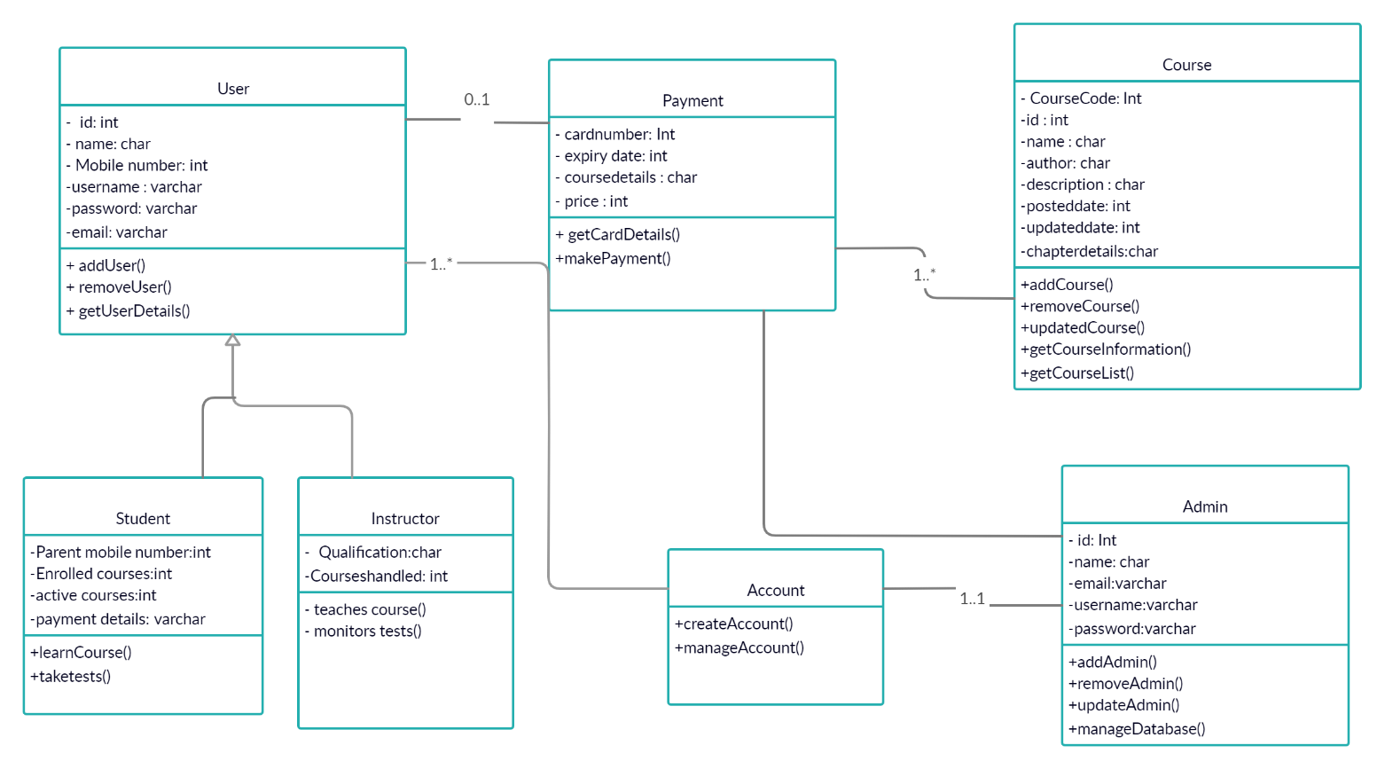

1. **Use Case Diagram :**

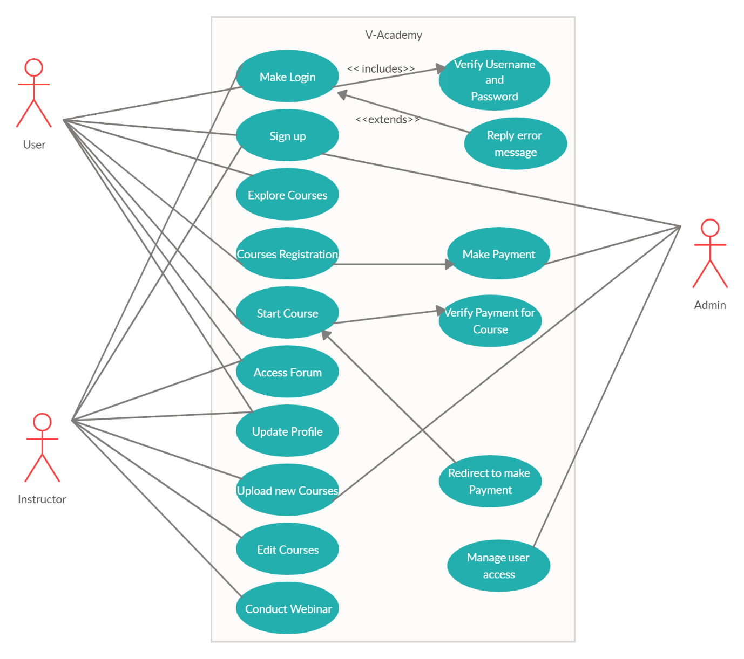

1. **Deployment Diagram :**

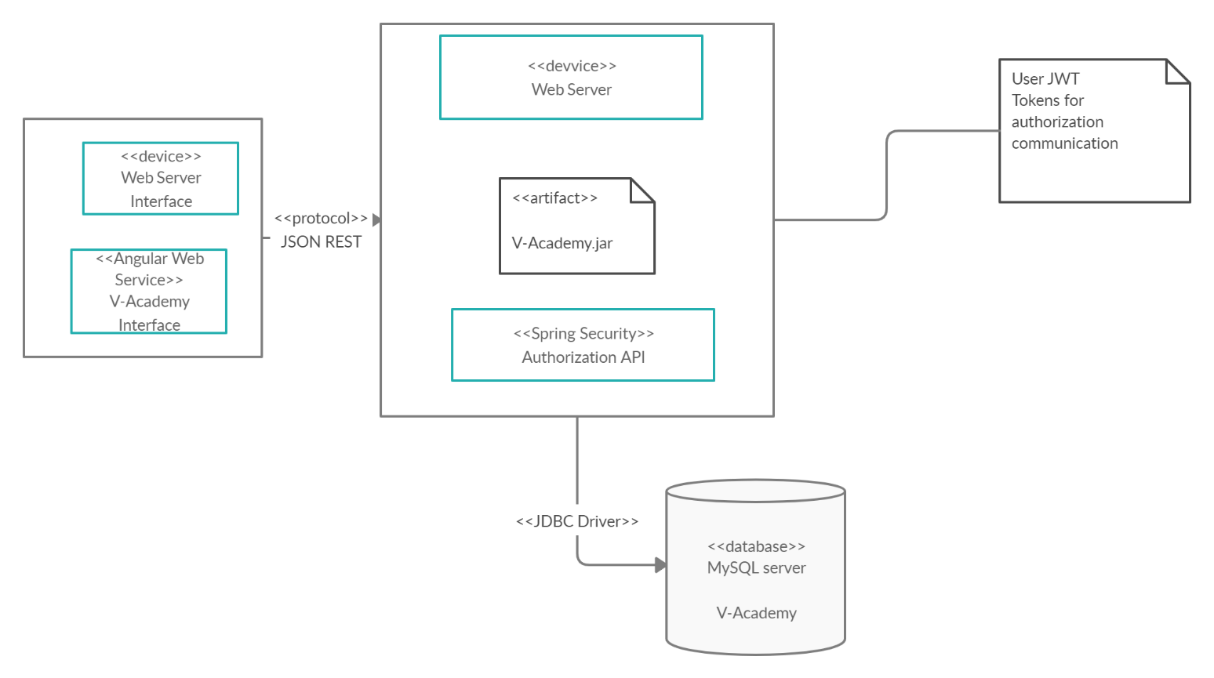

1. **Sequence Diagram :**

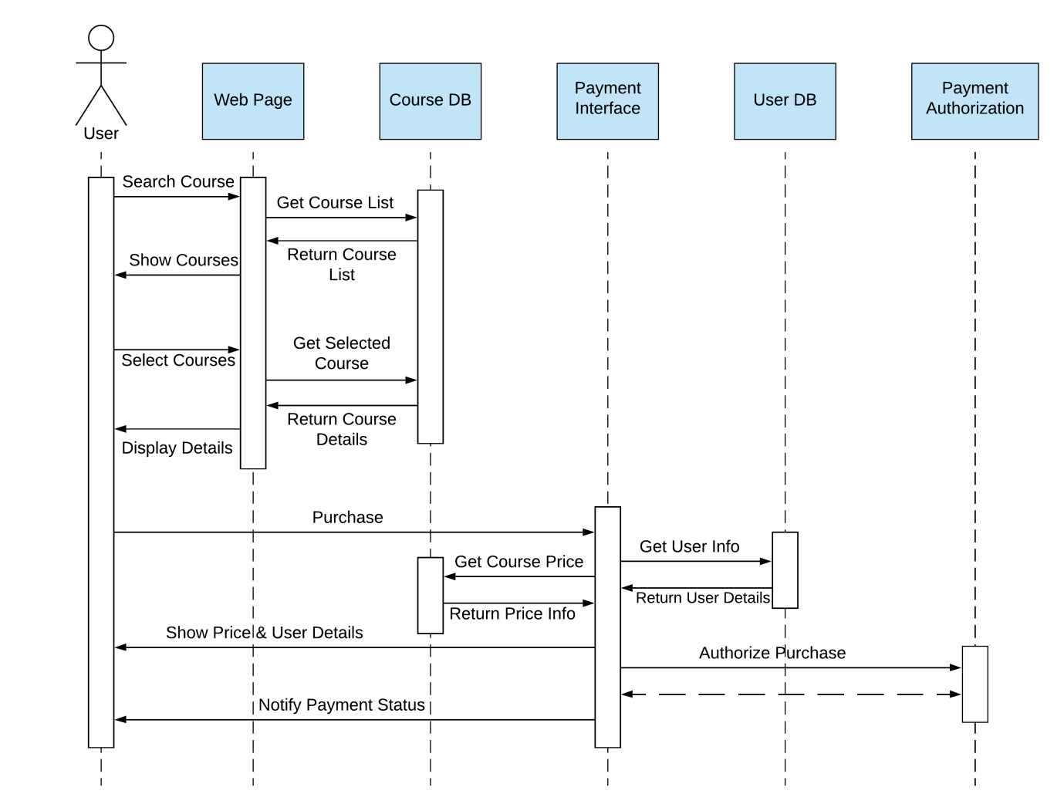

1. **State Diagram :**

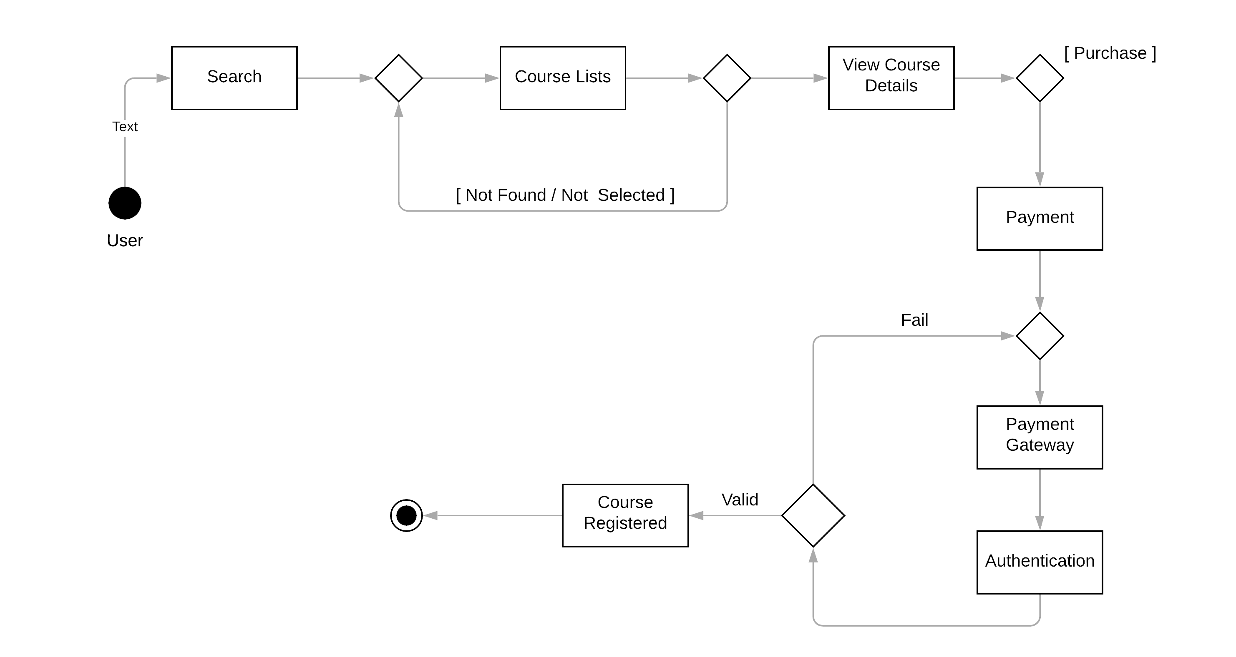

1. **Package Diagram :**

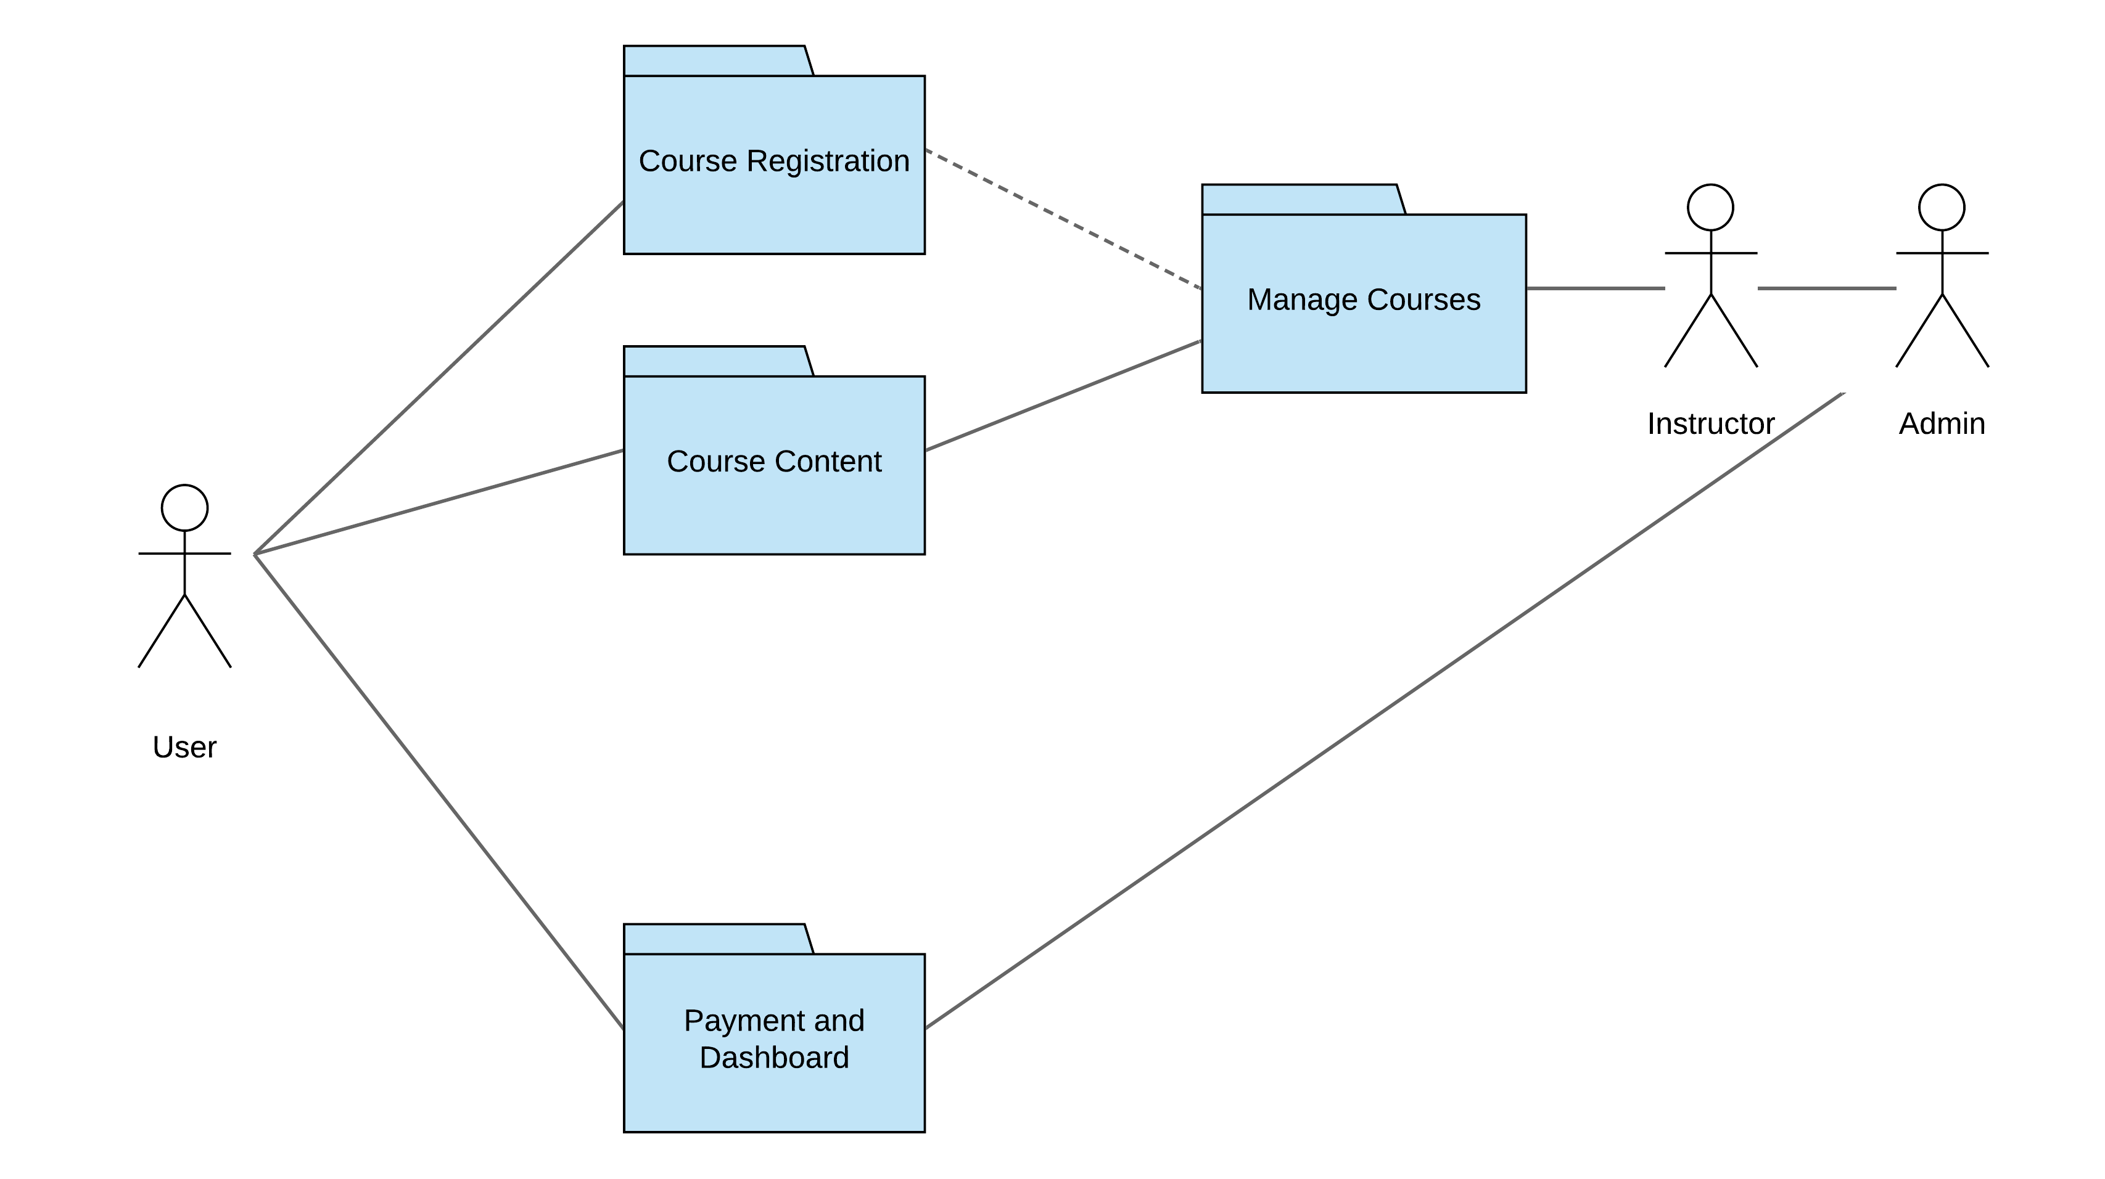

# Detailed Design for Module: **Admin**

This section describes the detailed design for the Admin module/sub-system.

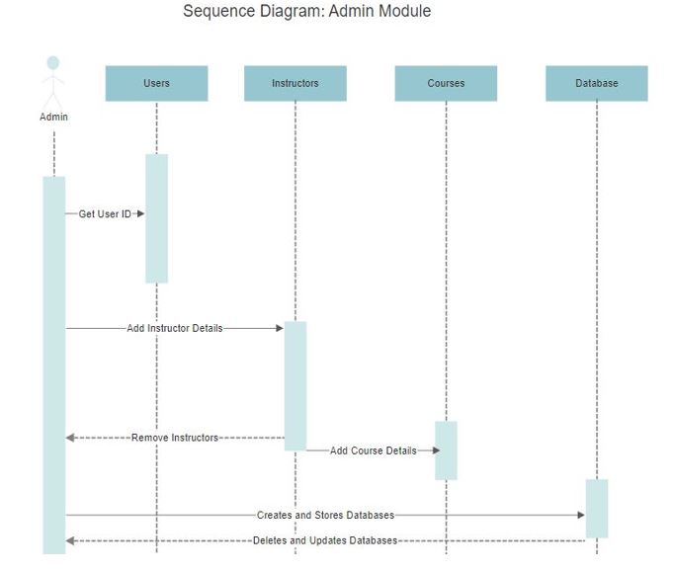

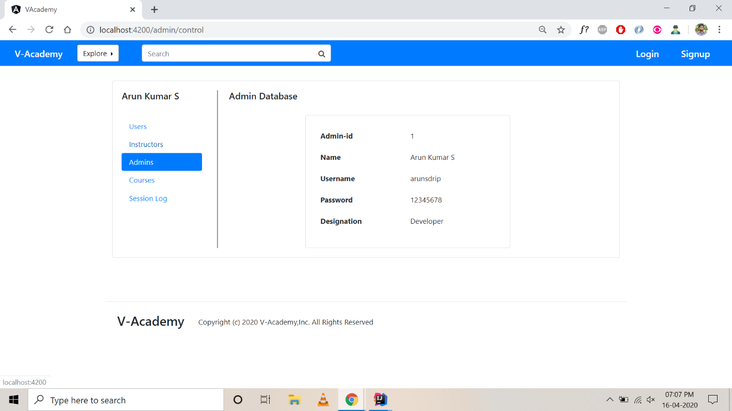

Screenshot of Admin Module

The webpage consists of a side menu and the main content.

**Users:** The user can access to the courses page where they will be given a user name and password.

**Instructors**: Instructors also have a username and password and they are used to mentor the students and teach the courses. They also have the authority to add courses.

**Admin:** The admin has the authority to give access to the instructors and they also have a username and password. They are also in-charge of the payment portal where the course fee can be paid.

**Courses:** Various courses are present and the users can select their desirable course and study. Apart from that mock tests are also present to check how well the user has understood the course.

**Session Log:** This section contains the details of whomever has visited the webpage.

## Detailed Design for Feature: ***Payment portal***

### **User Profile**

* Registered User
* Admin Assessor

### **Navigation Map**

Buy Course 🡪 Payment Page 🡪 User Profile Page

### **UI Screen Design**

|  |  |
| --- | --- |
| **Page Summary** | |
| **Name** | Payment portal |
| **Description** | The user retrieves the customer information based on the search criteria such as File ID, last name, first name, middle name, business name, SSN/TIN, address, city, state and/or zip. |
| **Use Case Number** | UC-002 |

#### *Screen Layout*

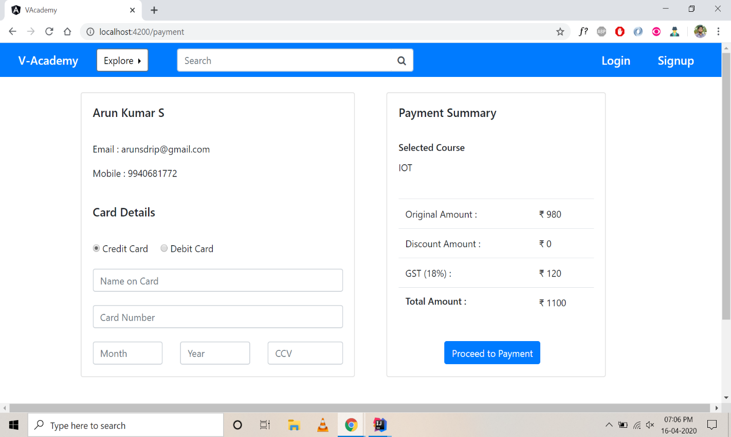

**Table to Display payment portal elements:**

|  |  |
| --- | --- |
| **User Details** | E-mail, Mobile Number |
| **Card Details** | Selection of card,  Enter name on card, card number, month, year, ccv |
| **Payment Summary** | Select the course, the original and discount amount is displayed with GST and proceed to payment |

#### *Validations*

|  |  |  |
| --- | --- | --- |
| **Error Trigger** | **Action** | **Description** |
| If the user group enters wrong Card number | Displays the message “Enter a valid Card number”. | Prompts the user to check and enter the valid data. |
| User entering the details of expired card | Displays the message “Invalid Account”. | Search the account of the user from database, if not found then it displays the following message. |

## Detailed Design for Feature: ***Courses Page***

### **User Profile**

* Add Course
* Remove Course
* Update Course
* Details of Students viewing Course
* Dashboard Details

### **Navigation Map**

[Describe the navigation map along with use case traceability of all screens for this feature.]

### **UI Screen Design**

|  |  |
| --- | --- |
| **Page Summary** | |
| **Name** | Course page |
| **Description** | The user retrieves the customer information based on the search criteria such as File ID, last name, first name, middle name, business name, SSN/TIN, address, city, state and/or zip. |
| **Use Case Number** | UC-002 |

#### *Screen Layout*

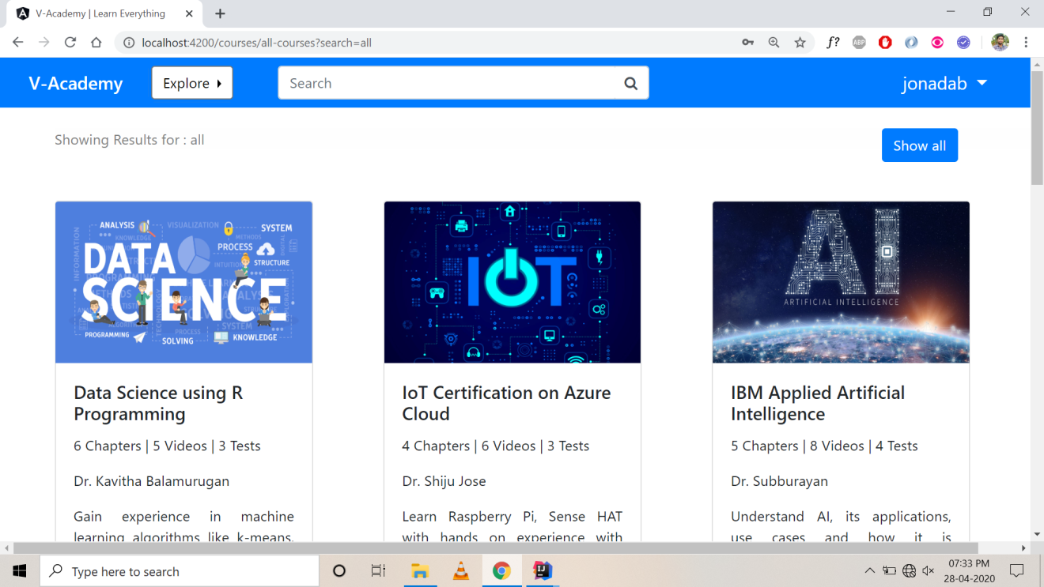

**Courses:** This webpage includes the courses in which and individual can select what type of course he/she is interested in and pursue.

**Explore :** This button is present where an individual can explore the courses which are present in the webpage.

**Search:** This bar is used where one can type the course, he/she wants to do and check whether that course is available.

**Show All :** This button can be clicked to display all the course which are available on the webpage.

#### *Validations*

|  |  |  |
| --- | --- | --- |
| **Error Trigger** | **Action** | **Description** |
| If the user group takes the unpaid course | Displays the message “Sorry not yet paid”. | Prompts the user to pay and take up the course. |
| User Logging in to the expired session | Displays the message “The session is expired; the new session will be updated soon”. | Search the courses validity from database, if not found then it displays the following message. |

# 4 Detailed Design for Module: SSO

This section describes the detailed design for the SSO module/sub-system.

*Sequence diagram : SSO*

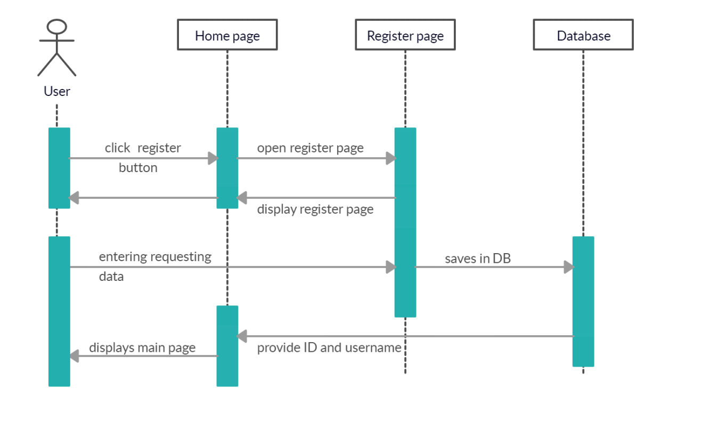

## Detailed Design for Feature: ***Home page***

### **User Profile**

* User Registration
* User Login
* Instructor Login
* Admin Login

### **Navigation Map**

Explore 🡪 Course List Page

Login / Signup 🡪 Login Page

Go to Forum 🡪 Forum Page

### **UI Screen Design**

|  |  |
| --- | --- |
| **Page Summary** | |
| **Name** | Home page |
| **Description** | The user retrieves the customer information based on the search criteria such as File ID, last name, first name, middle name, business name, SSN/TIN, address, city, state and/or zip. |
| **Use Case Number** | UC-002 |

#### *Screen Layout*

Screen shot of Home Page

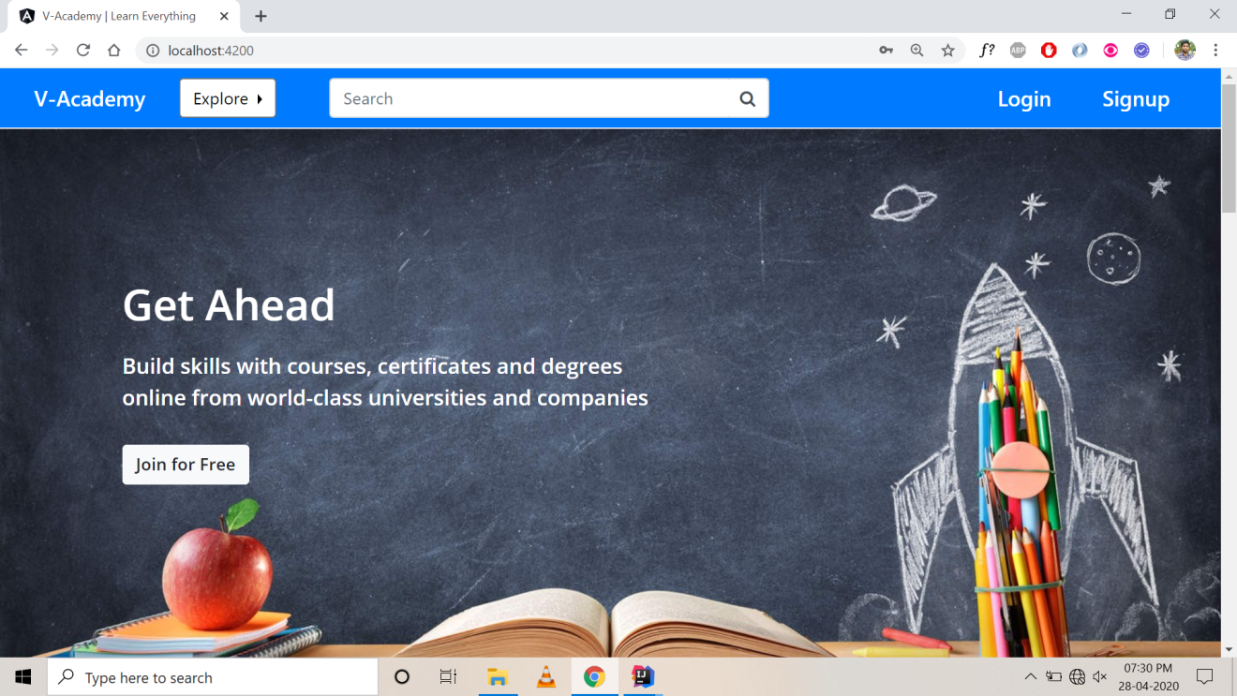

**Signup :** The user can access to the courses page by registering through this signup button.

**Login :** Once registration is over the user can assess the courses by loging

In into the login button.

**Search tag :** This tag helps the user to search the courses required by them to know whether it is present in this website or not.

#### *Validations*

|  |  |  |
| --- | --- | --- |
| **Error Trigger** | **Action** | **Description** |
| If the user group enters wrong Password or User name | Displays the message “Invalid User name”. | Prompts the user to check and login once again. |
| User Logging in before Registering | Displays the message “User not Found”. | Search the user from database, if not found then it displays the following message. |

## Detailed Design for Feature: ***Courses Page***

### **User Profile**

* View Course
* Course price details
* Dashboard Details

### **Navigation Map**

Course List Page 🡪 Course Details Page [Selected Course]

### **UI Screen Design**

|  |  |
| --- | --- |
| **Page Summary** | |
| **Name** | Course page |
| **Description** | The user retrieves the customer information based on the search criteria such as File ID, last name, first name, middle name, business name, SSN/TIN, address, city, state and/or zip. |
| **Use Case Number** | UC-002 |

#### *Screen Layout*

Screen shot of Courses Page



**Courses:** After registration it shows various courses such as Data Science, IOT, Artificial Intelligence etc. and the user can start the required course.

#### *Validations*

|  |  |  |
| --- | --- | --- |
| **Error Trigger** | **Action** | **Description** |
| If the user group takes the unpaid course | Displays the message “Sorry not yet paid”. | Prompts the user to pay and take up the course. |
| User Logging in to the expired session | Displays the message “The session is expired; the new session will be updated soon”. | Search the courses validity from database, if not found then it displays the following message. |

# 

# Database Design

|  |  |
| --- | --- |
| **Models** | **Tools** |
| Database Entity Relationship Diagrams | ERWin |
| Object Models | Rational Rose |

## Entity Relationship Diagrams

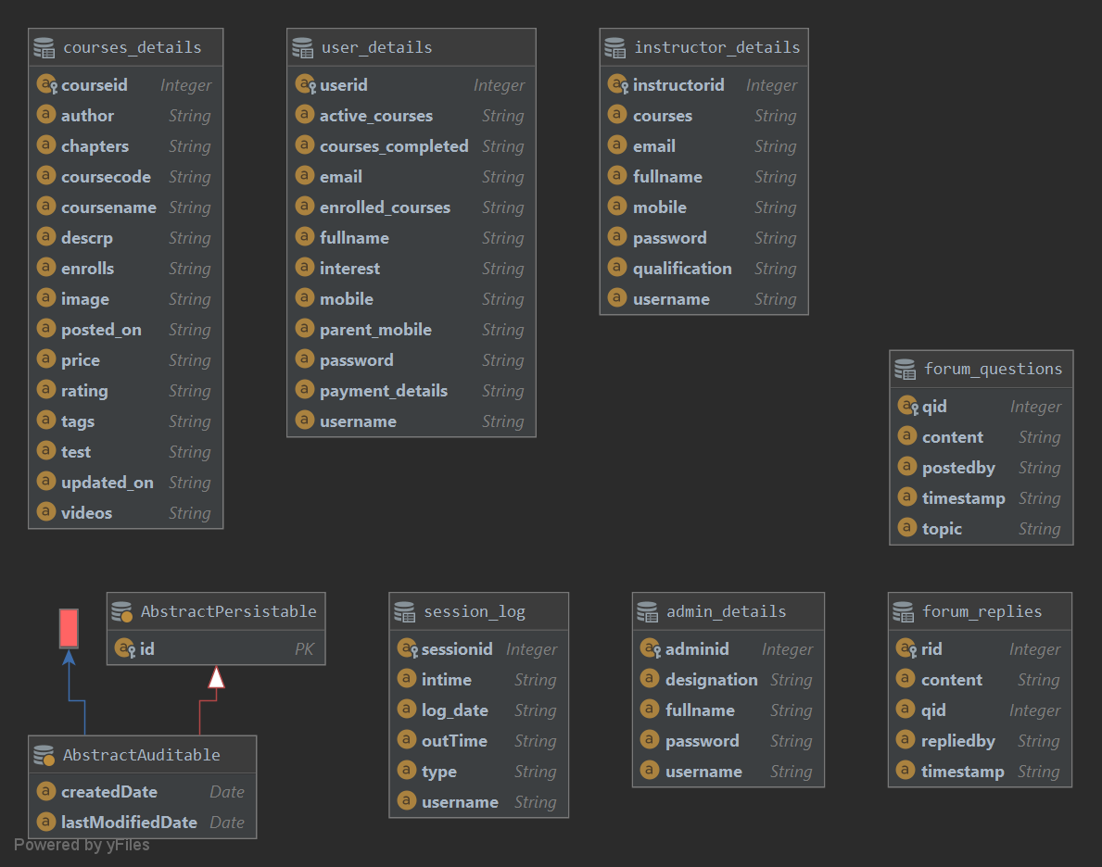

# Packaging/Folder Structure and System Artifacts

**[Sample structure**

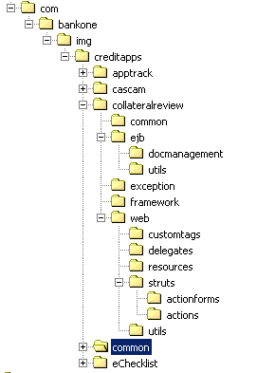

**End Sample Structure]**

## System Artifacts

[Provide information on the Registry structure, INI files, property files, configuration files, etc.]

# Core Technical Services Design

[This section describes the detailed design and usage pattern for the core technical services of the system.]

## Persistence

[This sub-section captures the detailed design and usage patterns of the persistence service for the application.]

## Inter-process Communication

[This sub-section captures the detailed design and usage patterns of the inter-process communication framework for the application.]

## Authentication and Authorization

[This sub-section captures the detailed design and usage patterns of the security services for the application.]

## Error Handling

This sub-section captures the detailed design and usage patterns of the error handling services for the application.]

## Logging

[This sub-section captures the detailed design and usage patterns of the logging framework for the application.]

## Transaction Management

[This sub-section captures the detailed design and usage patterns of the Transaction Management service for the application.]

## Other Applicable Technical Services

[This sub-section captures the detailed design and usage patterns of the other core technical services to be handled by the system such as the installation mechanism, failure prevention, fault tolerance, caching design, internationalization, validation framework, client and server initialization, error handling, etc.]

# 9 Non Functional Requirements

# Appendix

[Presents information that supplements the design specification.]

## Design Metrics to be Used

[A description of all design metrics to be used during the design activity is listed here.]

## Supplementary Information

[Provide as required.]

## DQI – Design Quality Index Checklist

This checklist shall be used to perform self-review as a reference while preparing software design.

